

Academic Skills and Team-Based Learning(4CI018)

Report Writing

<Individual Report>

Student Id : 2329584

Student Name : Akriti Kumari Dev

Group : L4CG5

Lecturer : Mr. Dipesh Shrestha

Word Count : 2605

Submitted on : 2023-02-12

**Abstract**

My knowledge from the curriculum on "Academic Skills and Team-Based Learning" are covered in mine final report. A complete set of professional requirements for an IT position is listed in this report. This report includes weekly blogs from the first semester, a sample video statement, professional papers, two reports based on IT company and professional organizations, an AI speech, and the final presentation slides.  This report is intended as the definitive and thorough summary of all the assignments we were given during the first semester of college**.**

**Acknowledgement**

I wish to take this opportunity to thank Herald College Kathmandu, Mr. Manish Deuja, the course director, and, most importantly, our instructor Mr. Ishwor Luitel for providing me with such a wonderful opportunity to advance my professional abilities. I   like to thank our tutor for helping us with all of the report's contents as well as all of the professors in this module for always being available when we needed them. The university has been extremely helpful in helping us with all of the tasks required to finish this project effectively. I also want to show my appreciation to The University of Wolverhampton for letting me put together this significant research.

**Table of Contents**

**1.** **Link to the Blogs** 1

**2. Link of Video Statement** 1

**3.** **Academic Report** 2

**3.1 Introduction** 2

**3.1.1. University of Wolverhampton** 2

**3.1.2. Herald College Kathmandu** 3

**3.2. Body** 4

**3.2.1 Fuse Machines** 4

**3.2.2 Curriculum of University of Wolverhampton** 5

**3.2.3Curriculum Distribution of HCK** 6

**3.3. Universities in the UK Vs Nepal** 8

**3.3.1 Nepali University** 8

**3.3.2 Foreign University** 8

**3.4. Critical Analysis** 9

**3.5. Future Relation** 10

**3.6. Conclusion** 10

**4.** **Professionalism Task** 11

**4.1.** **CV** 11

**4.2. Cover Letter** 12

**4.3. Graduate Form** 13

**5.** **AI Speech** 23

**6.Professional Organization Report** 24

**6.1.1. Introduction** 24

**6.1.2. Association for Machinery Computing** 24

**6.2. Body** 25

**6.2.1. ACM** 25

**6.2.2. Pros of Membership** 25

**6.2.3 Cons of Membership** 25

**6.3. Conclusion** 26

**7.Final Presentation** 26

**8. References** 36

**Table of Figures**

**Figure 1:Logo of University of Wolverhampton** 2

**Figure 2: Logo of Herald College Kathmandu** 3

**Figure 3:Curriculum Distribution of University of Wolverhampton (BCS)** 6

**Figure 4 :Curriculum Distribution of Herald College Kathmandu** 7

# 

# **Link to the Blogs**

|  |  |
| --- | --- |
| Week | Link |
| Week 1 | https://akritid10.wordpress.com/first-week-of-my-college/ |
| Week 2 | https://akritid10.wordpress.com/2022/12/01/reason-to-choose-herald-college/ |
| Week 3 | https://akritid10.wordpress.com/2022/12/11/week-3rd/ |
| Week 4 | https://akritid10.wordpress.com/2022/12/17/week-4/ |
| Week 5 | https://akritid10.wordpress.com/2022/12/26/week-5/ |
| Week 6 | https://akritid10.wordpress.com/2023/01/02/week-6/ |
| Week 7 | https://akritid10.wordpress.com/2023/01/10/week-7/ |
| Week 8 | https://akritid10.wordpress.com/2023/01/14/week-8/ |
| Week 9 | https://akritid10.wordpress.com/2023/01/20/week-9/ |
| Week 10 | https://akritid10.wordpress.com/2023/01/31/week-10/ |
| Week 11 | https://akritid10.wordpress.com/2023/01/30/week-11/ |
| Week 12 | https://akritid10.wordpress.com/2023/02/09/week-12/ |

# **2. Link of Video Statement**

<https://drive.google.com/file/d/1USedkxb5q9sVvQpsQ06PjyQYuUsafX9U/view?usp=share_link>

# **Academic Report**

**Abstract**

The purpose of this article is to discuss about advantages that Fuse Machine will experience after addition of aspirants from the Herald College Kathmandu, along with reasons this company must think about doing so. In this report we can see the courses taught at the college that aid in the projects undertaken by the company and services supplied by the company. One will be able to comprehend the justifications for and advantages of hiring graduates from this college after reading this study.

## **3.1 Introduction**

Among all major renowned IT companies in Nepal, Fuse Machine Nepal private limited is also one of them. This company was established in 2013 and although its headquarters are in New York, it also has operations in the Dominican Republic, Canada, and Nepal. Fuse Machine is a provider of enterprise AI facilities and solutions that helps underprivileged organizations find AI education, products, and jobs (Fuse Machine, 2022). It employs 50 to 55 new employees as it is a US-based company with over 300+ people, making it a relatively large corporation.

### **3.1.1. University of Wolverhampton**



**Figure 1:Logo of University of Wolverhampton**

The Wolverhampton University, which is based at city of Wolverhampton, was established in 1827. Over 380 both undergrad and grad programs are available. The University of Wolverhampton, which was chosen because of the universities cutting-edge technology, is enthralling to more than 23000 students. The Uni of Birmingham is ranked number 601 globally. Additionally, technological, analytical, industrial, as well as basic curriculums had been created for the library. It is associated with a number of foreign universities, Herald College Kathmandu being one among them (University of Wolverhampton, 2022).

### 

### **3.1.2. Herald College Kathmandu**



**Figure 2: Logo of Herald College Kathmandu**

Herald College Kathmandu, being highly esteemed British campuses in Kathmandu, was founded in 2016.This college is situated at Naxal, Bhagwati Marg. The establishment is connected to the University of Wolverhampton., UK for undergraduate certificate and it gives the finest UK University education with fair prices. It gives undergraduate degree in both IT and Business. Herald College teaches students in different methods i.e., LTW format (Lecture, Tutorial and Workshop that facilitates understanding for alumni (Herald College Kathmandu, 2022).

## **3.2. Body**

### **3.2.1 Fuse Machines**

As a CEO of Fuse Machines, Sameer Maskey, a graduate of a Colombian University, arrived in Nepal six years earlier. He sought up three people who could work with mathematical formulas (Nepali Times, 2017) from Kathmandu institutions. A global organization called Fuse Machines is committed to developing cutting-edge artificial intelligence (AI) applications. Fuse Machines assists businesses in identifying possibilities where AI may be used to transform and expand their operations (Topio Networks, 2022).

Some of the projects of Fuse Machine are listed below:

* EHR/Diagnosis Automation
* Mental Health App
* Conversational Robot for Kids
* Health and Wellness
* Software Customization Tool

The manpower company is demanding for their projects are:

* Python Developer
* Software Engineer (Back End)
* UI/UX Designer
* DevOps Engineer
* QA Engineer
* Data Engineer
* Software Engineer (JavaScript)

### **3.2.2 Curriculum of University of Wolverhampton**

The University of Wolverhampton provides following computer science programs:

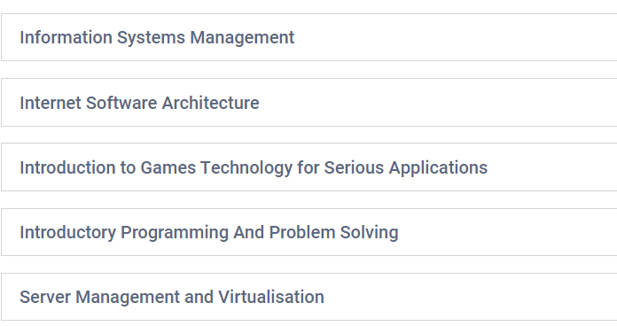

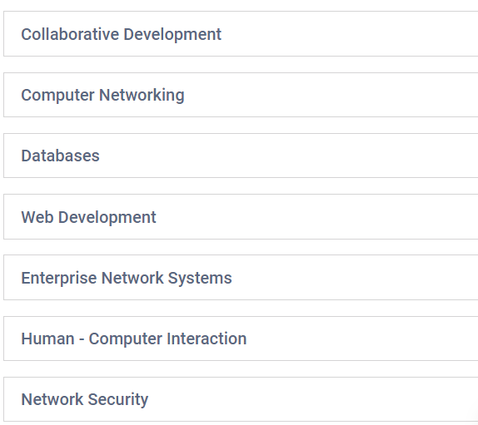

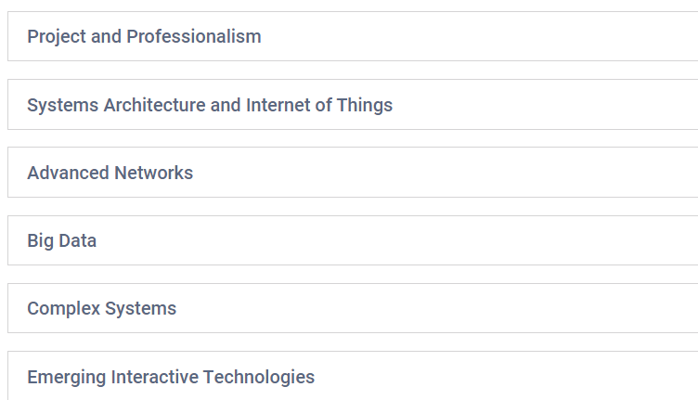

**Figure 3:Curriculum Distribution of University of Wolverhampton (BCS)**

### **3.2.3Curriculum Distribution of HCK**

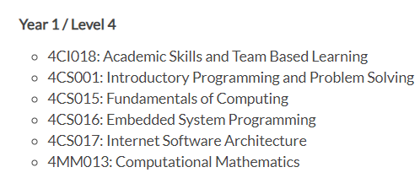

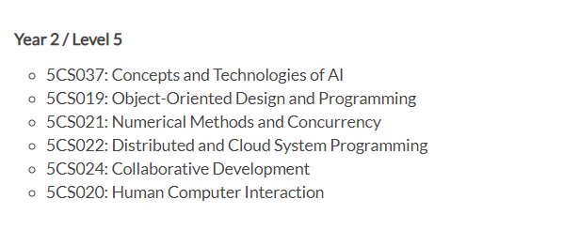

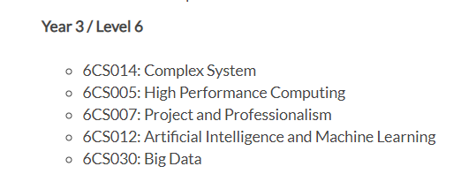

**Figure 4 :Curriculum Distribution of Herald College Kathmandu**

Consequently, focus of the modules for this associate degree program is indeed artificial intelligence. Building a solid foundation for computer science is facilitated throughout the first semester. The basics of internet architecture and programming for embedded systems are covered in more detail in the second semester. A key component of studying artificial intelligence is computational mathematics. They research collaborative development and object-oriented programming. The final module of the year is entrepreneurship and professionalism. Students learn where and how to construct a professional assignment in this subject. This course gives students the skills they'll need to find employment after graduation. Practical information that can be used in everyday circumstances is the goal of every module. You can enter the field of computers right away with the help of this BIT course, which serves as a great steppingstone (Herald College Kathmandu, 2023).

## **3.3. Universities in the UK Vs Nepal**

The duration of the course load is one of the most important differences between institutions in Nepal and the UK. Obtaining a undergrad degree in science normally takes 3-years in the United Kingdom, but four years to accomplish one in Nepal. It used to take three years to complete university studies in Nepal, but from 2012 AD, the program was changed to a four-year course (Tribhwan University, 2023). The United Kingdom is home to some of the most renowned universities in the world, and its graduates are truly capable of competing on a worldwide scale (Study In The UK, 2020).

### **3.3.1 Nepali University**

By establishing the first institution, Tri-Chandra College, in Nepal in 1918, the country's history of higher education officially began. It was only the university which came in function until 1985. After that, the council admitted to the idea of a system of multiple universities, and Mahendra Sanskrit University was founded. (University Grants Commission, 2018). Kathmandu, Purbanchal, and Pokhara Universities were eventually founded.

### **3.3.2 Foreign University**

Numerous institutions in Nepal are partnered with abroad universities, including the British College, Islington College, and Herald College Kathmandu etc. The courses that these colleges offer are based on the course modules of the universities to which they are attached, and they typically last between three and four years. Instead of emphasizing theory, they just pay attention to practical knowledge. There are requirements for theoretical modules in some module components.

## **3.4. Critical Analysis**

The presence of Fuse Machines is global. They recruit across the globe for engineers and data analysts. Approximately 200,000 data analysts are expected to be needed in the US during the next five years, with the bulk of them working in the government. For Nepal's young and exceptional learners, Fuse Machines provides a range of possibilities.

1. Python Developer- Beginning with the first semester, courses in Herald College Kathmandu concentrates on programming languages like Python and Java. The students are offered various programming language-related coursework, coding challenges, and workshop projects, all of which allow them to enhance their knowledge of the particular programming language. As time goes on, the college offers a variety of programs linked to the Python programming language that aid students in becoming productive Python developers.
2. Software Engineer (JavaScript)- There is a web technology curriculum in the first semester that teaches individuals about CSS, HTML, and JavaScript. They place a greater emphasis on JavaScript, which improves individual knowledge and prepares them for the future. Various programs are held to help students improve their knowledge and become professional software engineers (JavaScript).
3. UI/UX Designer- In HCK, there are various communities that supply students with ideas for designing, presentations, podcasts, and so on. Students in the UI/UX designing community are taught about designing icons and buttons, making logos, and anything else related to UI/UX design. They also hold several design-related programs that will assist them in becoming well-trained designers.
4. DevOps Engineer- The objective of the Herald College Kathmandu course is on programming languages, along with designing and other external concepts. The major objective of the development platform in Herald College Kathmandu is to present alumni about basic and intermediate knowledge of testing and designing.

## **3.5. Future Relation**

Herald alumni and the IT AI-related enterprise Fuse Machine will continue to have a robust and mutually beneficial cooperation in the future. The technical expertise, problem-solving abilities, and flexibility of Herald graduates will be highly sought after given the quick development of technology and the expanding significance of AI in the industry. In addition, Herald will ensure that its graduates are prepared to meet the changing demands of the sector by investing in continual learning and improvement. The innovative approach of the organization and the graduates' combined experience will help both parties succeed and expand. The likelihood is high that this collaboration will continue to be an invaluable resource for the graduates and the business in the future.

## **3.****6. Conclusion**

# Overall, we can say that due to their skill at communicating any subject to a big audience, bachelors are a good fit in this regard. Indeed, Fuse Machines is seeking recent graduates with the capacity to handle huge amounts of data and analyze it. Graduates from Wolverhampton could contribute significantly to the company if hired. For every open position at Fuse Machines right now, graduates of Wolverhampton are fully qualified. Graduates will be qualified for any possible AI-related employment opportunities as the field is now in a state of bloom.

I would like to recommend Fuse Machine as a consultant for them to demonstrate interest in Herald College Graduates. The students are skilled at working in a team and are also adept at solving problems and coming up with original solutions. Additionally, they are equipped with the skills required for every job vacancy now. During, their last year, graduates are required to finish 1-year project that can be used as expertise for any maker role. Future requirements and projects can be completed by Herald alumni as the course is revised annually. Hiring graduates of Herald is unquestionably a smart move because the courses covered there correspond to the work requirements at Fuse Machine.

# **Professionalism Task**

## **CV**

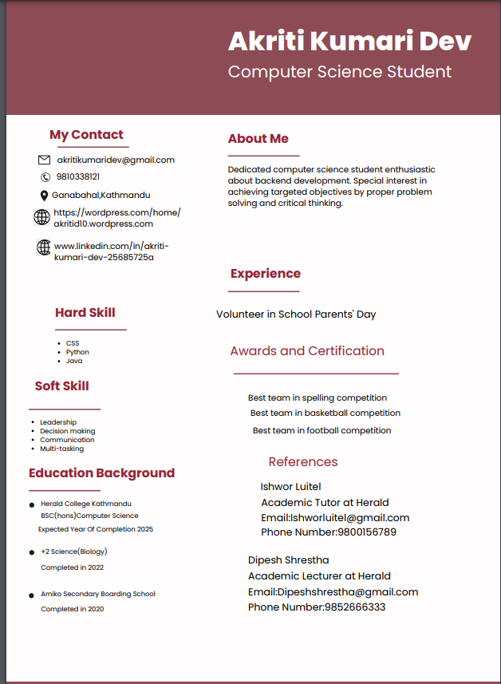

## **4.2. Cover Letter**

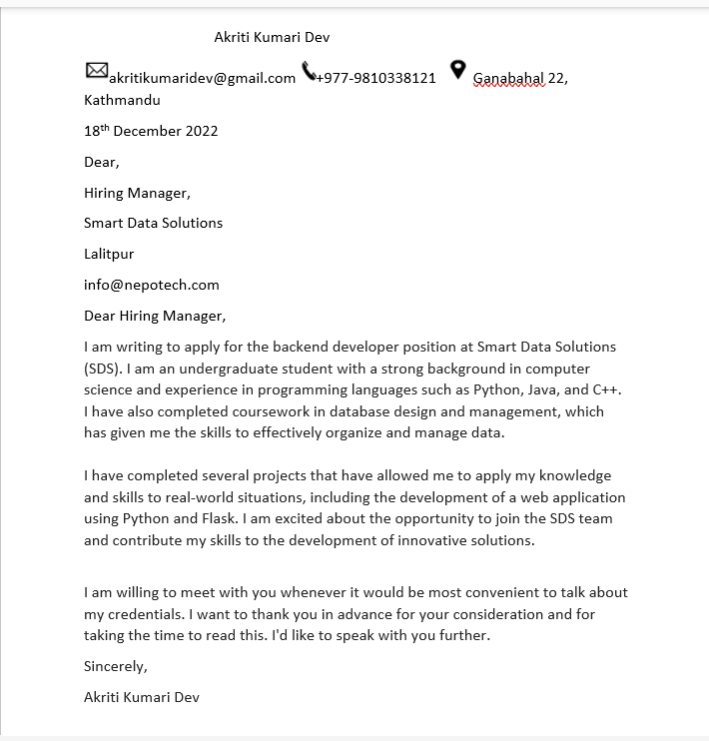

## **4.3. Graduate Form**

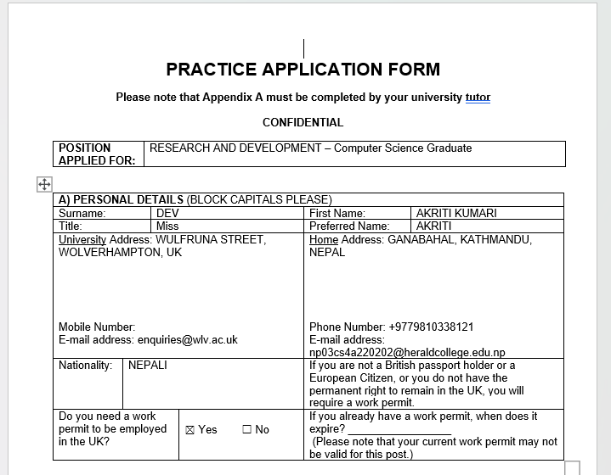

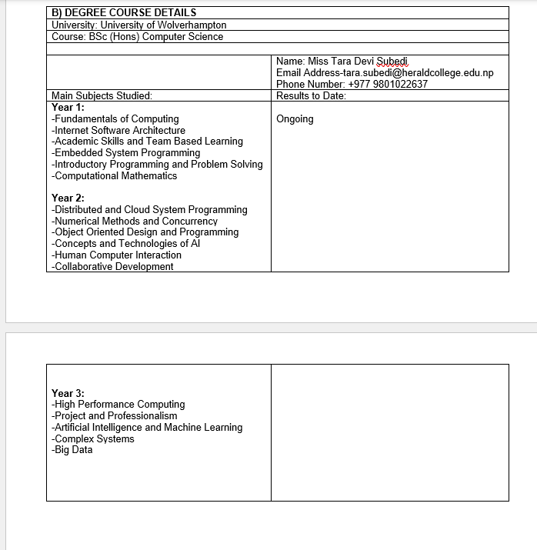

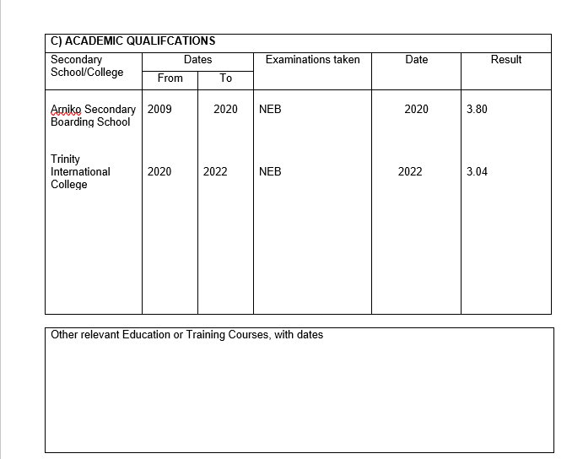

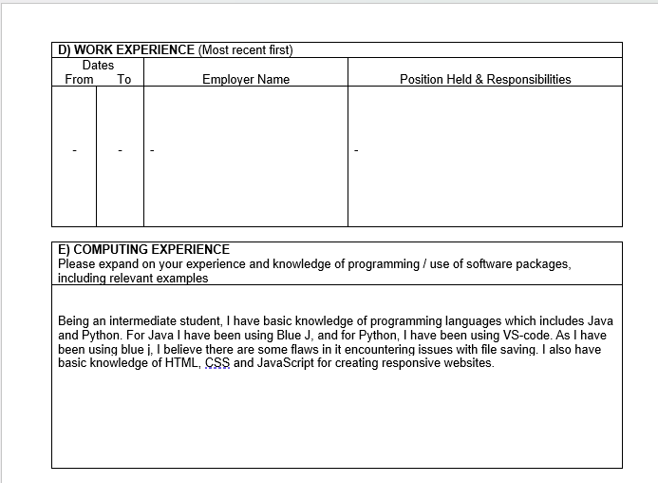

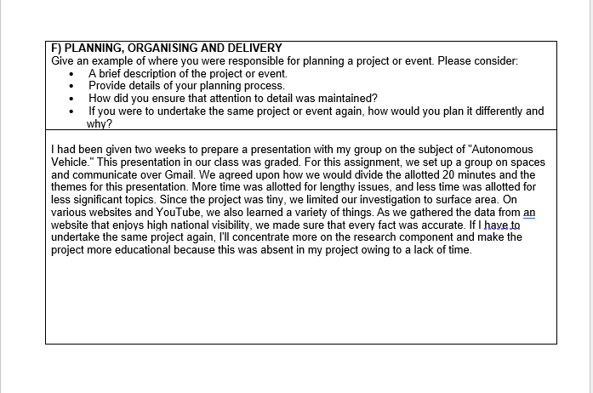

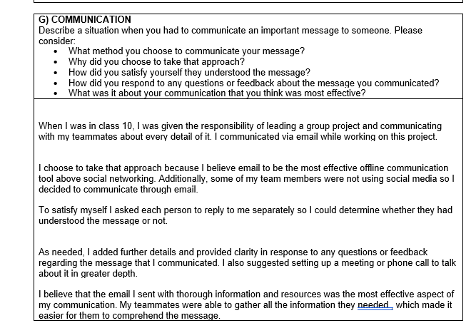

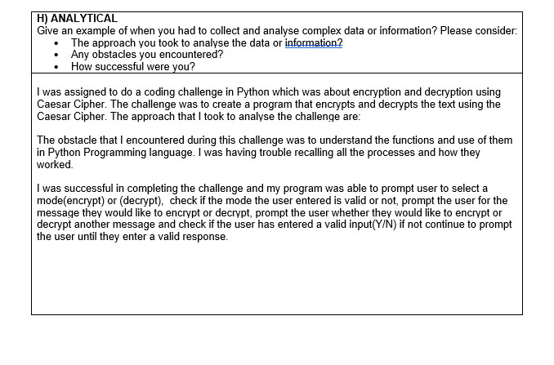

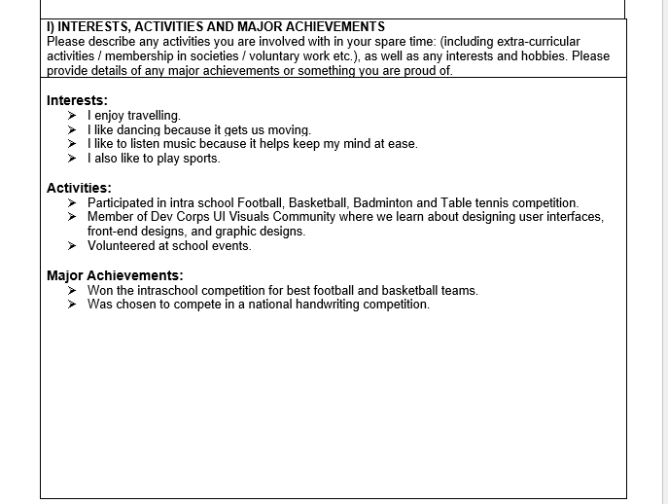

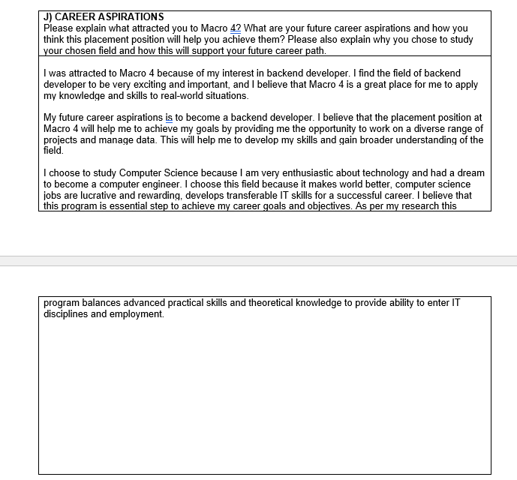



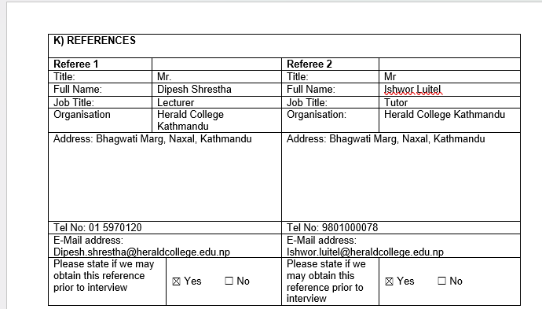



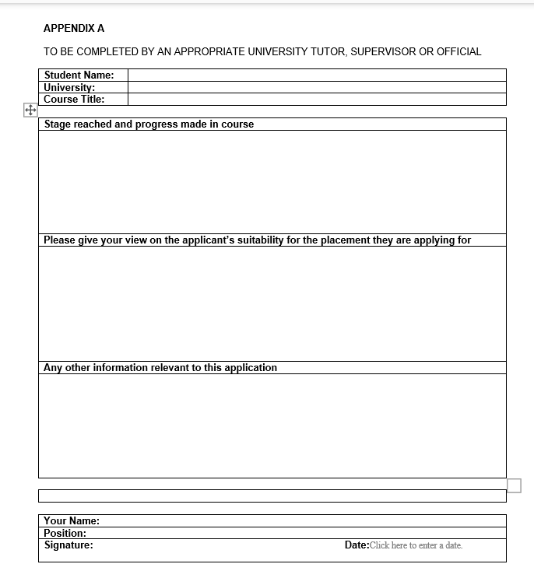

# **AI Speech**

**Intelligent robots will eventually replace human in the workforce.**

As technology continues to evolve, intelligent robots that can complete previously thought-of human-only tasks have also been created. These robots, often referred to as Artificial Intelligence (AI) or Machine Learning (ML) systems, have the capacity to learn from and adjust to new circumstances, which makes them extremely effective and affordable. As a result, it is conceivable that humans will eventually be replaced by robots in the workforce. The cost-effectiveness of robots is one of the primary causes of this. They are more productive than human laborers because they need no upkeep and can work long hours without becoming weary. Robots can also carry out activities that are too risky or challenging for people to complete, such operating delicately or working in unsafe conditions. Robots can also be programmed to carry out a range of jobs, making them versatile and adaptable to various sectors. For instance, self-driving cars and drones are already employed in delivery and transportation, while robots are used in manufacturing, healthcare, and other areas. Robots will grow more sophisticated and capable of handling more difficult tasks as technology advances. It's crucial to remember that this change could possibly have adverse effects. Robotic labor replacing humans could result in job losses and economic instability. This may both exacerbate already-existing social and economic problems like income inequality and generate brand-new ones. Governments and organizations should make plans to retrain and re-employ displaced workers as well as offer assistance to individuals who are negatively impacted in order to lessen these negative effects. In conclusion, it is likely that humans will be replaced in the workforce by intelligent robots. This change could lead to better efficiency and lower costs, but it could also have a negative influence on society. Governments and organizations must take action to lessen these negative effects and assist people who are negatively impacted by the change.

# **6.Professional Organization Report**

**Abstract**

This document gives a broad synopsis about Association for Computing Machinery (ACM), an experienced corporation, along with information on its principal objectives. The advantages of becoming a member of such a community are also mentioned. The people who are interested in learning about the business community that is based in the technology and computer industry are the main target audience for this report. If people should join such a community or not will be clear to the reader by the report's conclusion.

## **6.1.1. Introduction**

### 

### **6.1.2. Association for Machinery Computing**

# 

A professional team for IT specialists and computer scientists is called ACM. It was determined in 1947, which seems as the leading scientific and educational software organization globally, consisting of more than 100,000 peoples distributed over 190 different nations. The goal of this company is to progress the field of computing as both a science and a career, as well as to make people aware of and encourage the use of computing technology for the good of all of us. This organization publishes a wide variety of journals, magazines, and newsletters as well as holding a number of technical conferences, seminars, and workshops to accomplish this purpose.  It is a recognized authority in the computing industry and has a massive impact on how technology will develop in the future and what kind of social benefits it will have (ACM, 2023).

# **6.2. Body**

## **6.2.1. ACM**

This corporation had already developed variety of technical and professional special interest groups (SIGs) with a specialty on computer fields. Members of these SIGs get the opportunity to interact with like-minded individuals and gain knowledge about recent advancements. It is a well-known organization in the computing industry, and so its representatives are honored for their achievements. The association participates in several programs aiming at advancing the public's awareness of computing and its impact on society in addition to its technical and professional activities. They aim to increase public awareness of the value of computer science education and offers materials to help teachers and educators in implementing computer science into their courses. The association gives a variety of distinguished prizes and honors (ACM, 2023).

## 

## **6.2.2. Pros of Membership**

Getting involved in this group could be quite helpful for those with an interest in the field of computing. As a member, they will get accessibility to a huge library of articles and materials, possibilities to go to conferences and events to advance your professional development, and the ability to network with other experts in the field. Company’s activities and products are also available at reduced prices for customer benefit. The opportunity to give back by volunteering and taking part in charitable work is another benefit of being a member of this corporation. In fact, joining the organization offers beneficial tools and chances for career advancement in the computing industry (ACM, 2023).

## **6.2.3 Cons of Membership**

As is common knowledge, there are drawbacks to every organization, and the same is valid for this company. One of the main drawbacks is expensive fees that may limit its range. The inclusion of underrepresented groups has not been a focus for the company, and the publication method has been criticized as being too slow. Its participant method has been criticized for lacking honesty and fairness, and companies' emphasis on computer science and technology may limit its reach and influence. Additionally, some of its information might be easily around, which would make it less useful for researchers who want to keep updated (IvyPanda, 2023).

# **6.3. Conclusion**

According to my research, this organization's membership should be determined by each member's needs and objectives.  Access to a large digital library, chances to network with other professionals, career assistance, discounts and savings, and chances to give back through volunteer work are all provided by this corporation. The membership is likely to be a wise investment if you're actively involved in the computing industry, aiming to advance your career, and want to maintain contact with people in the sector. Membership may not be beneficial for you if, you are not actively involved in the area or do not gain from its services.

# **7.Final Presentation**



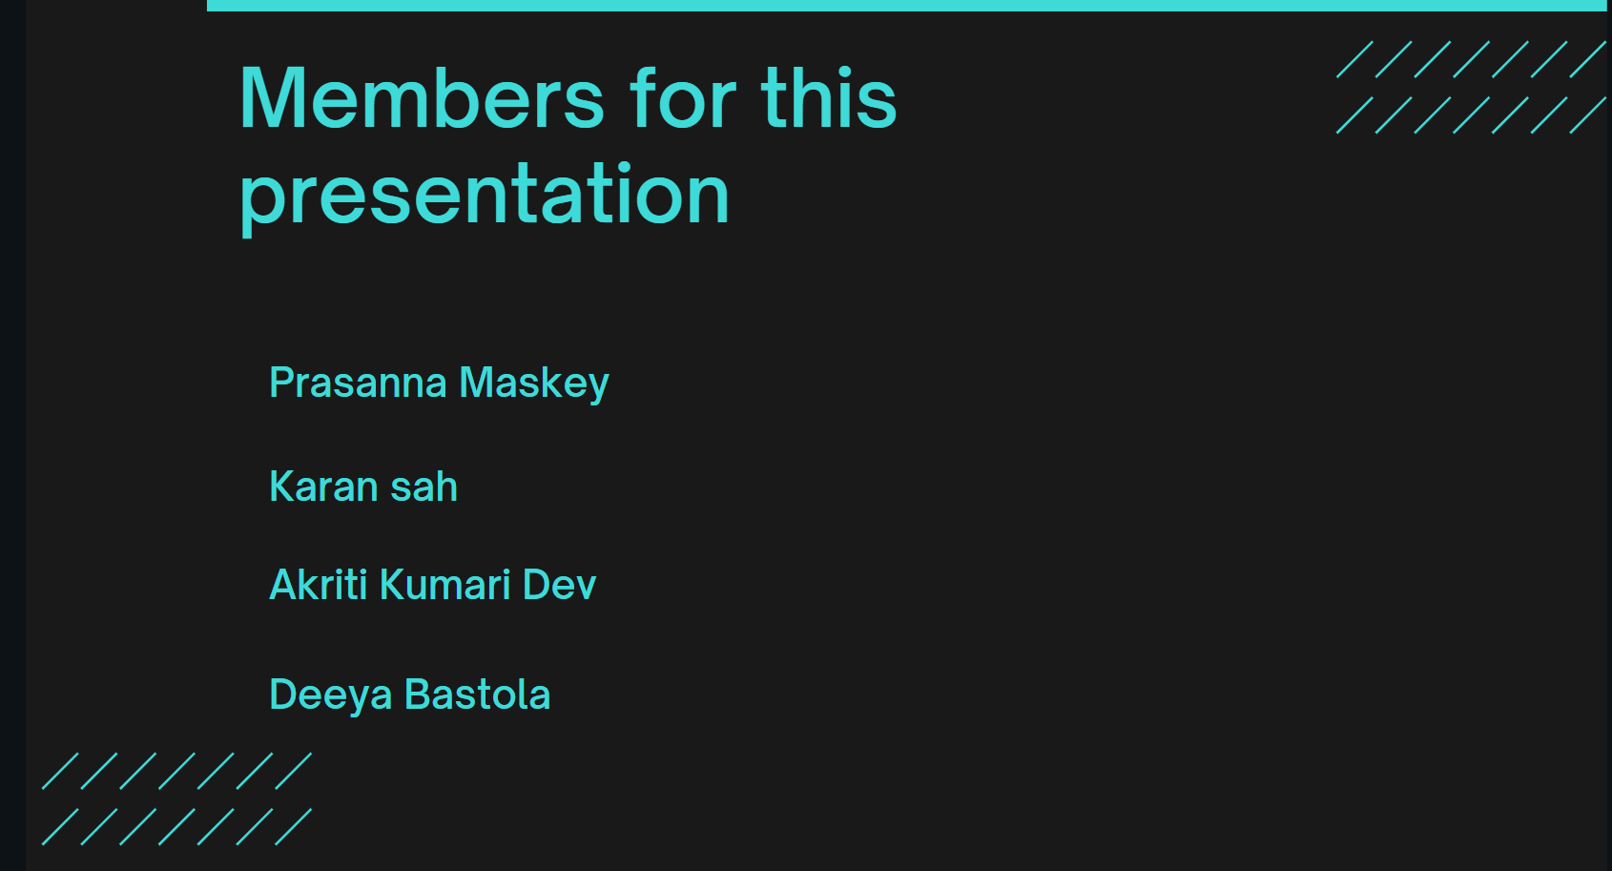

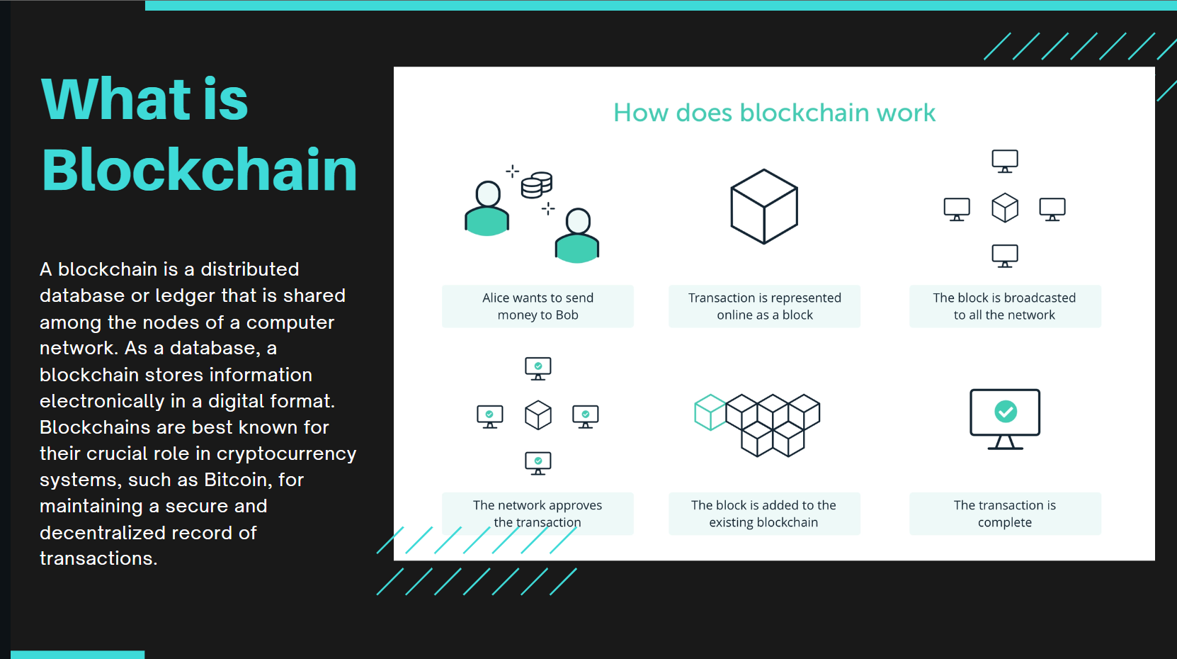

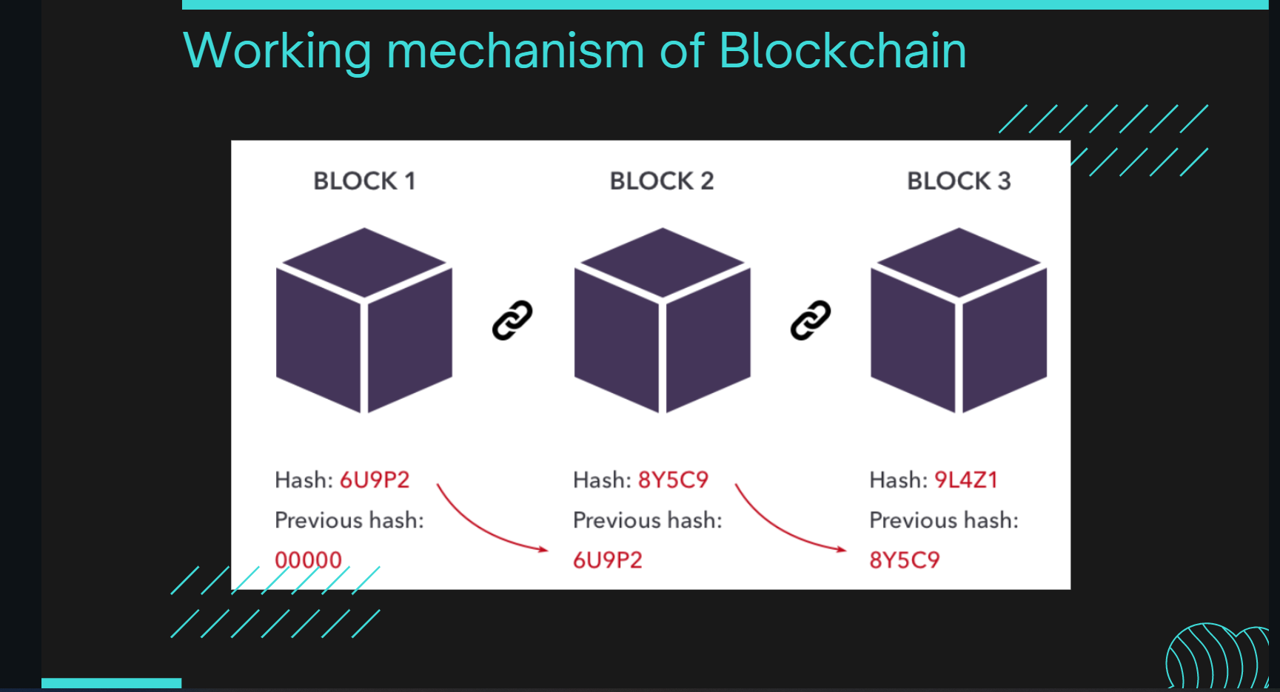

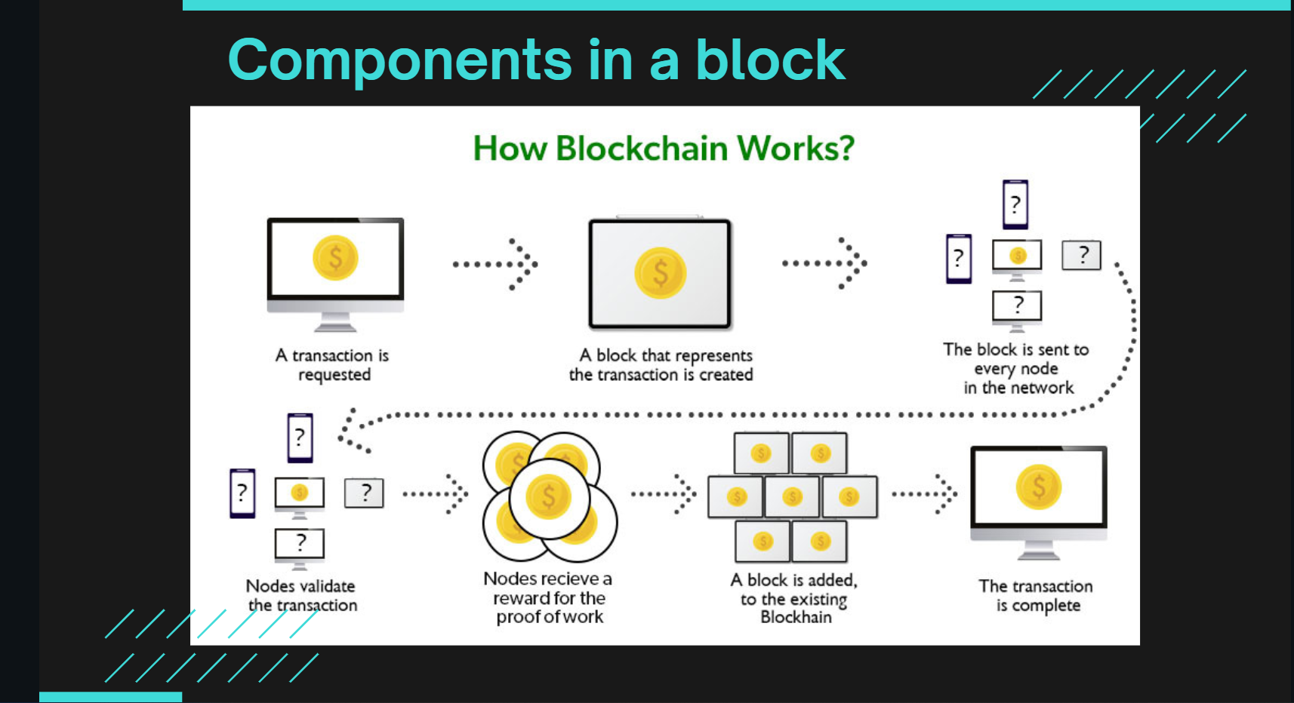

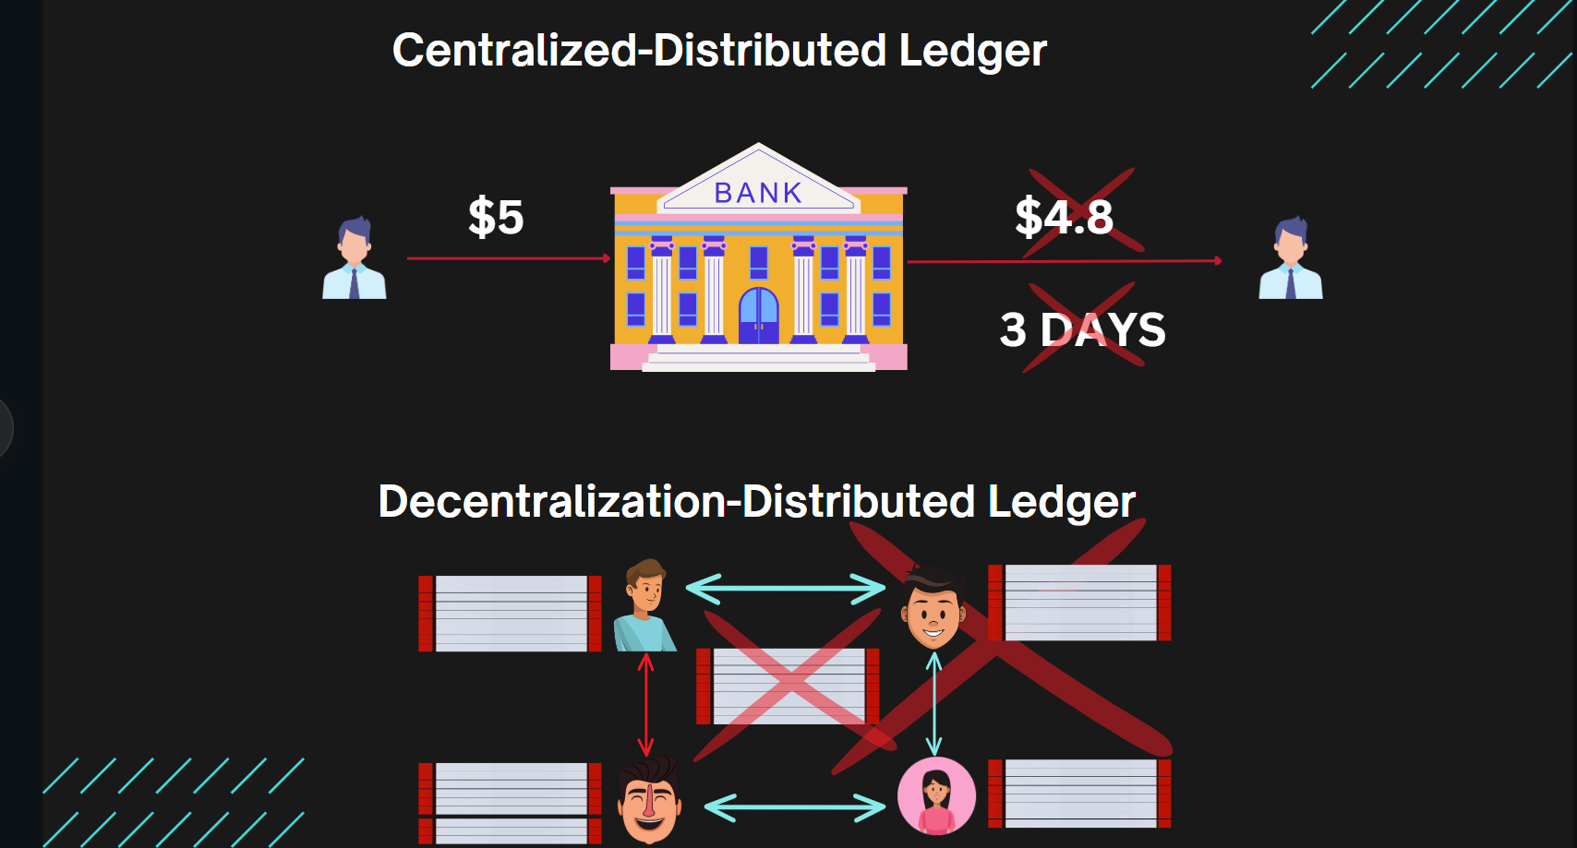

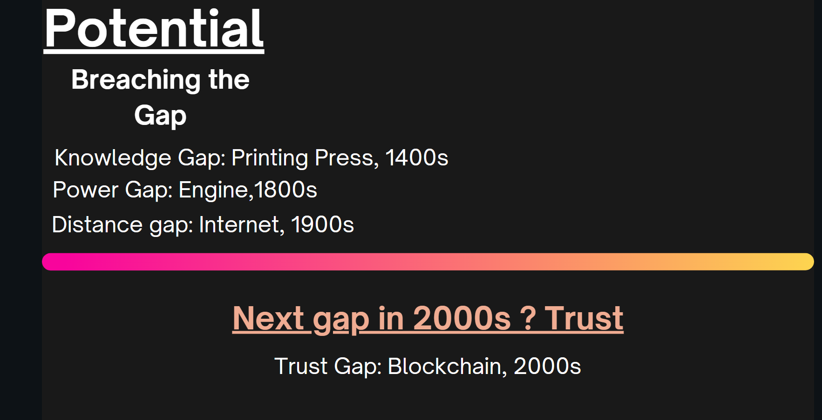

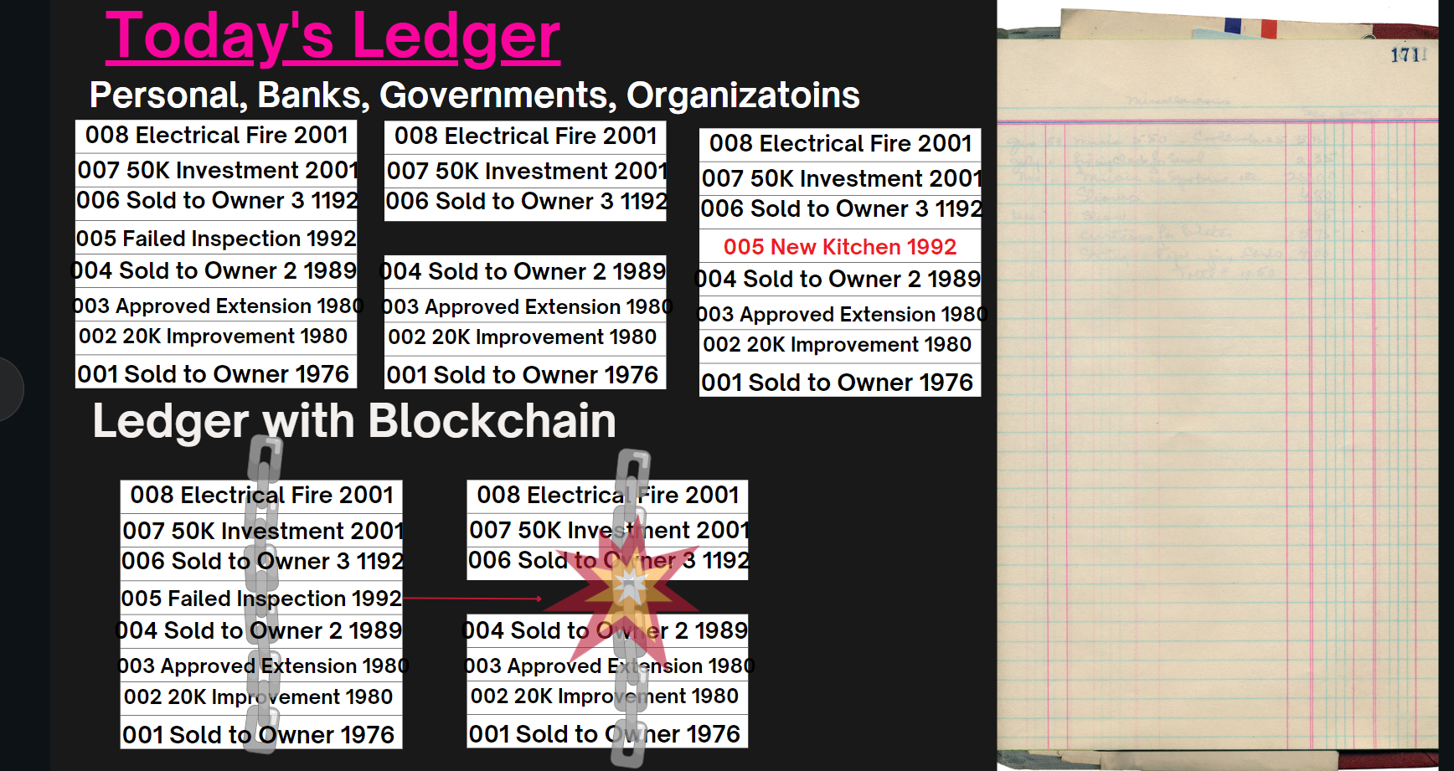

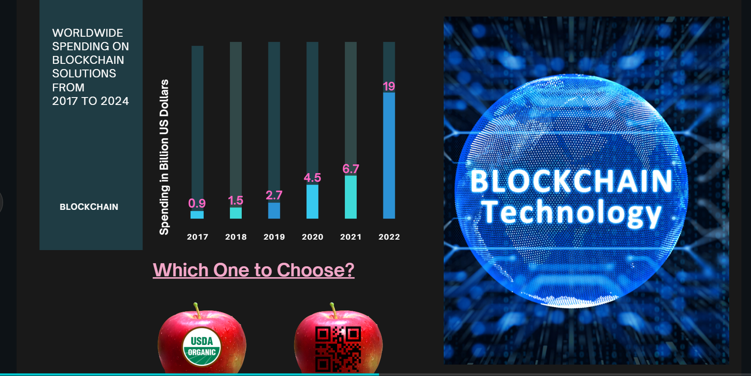

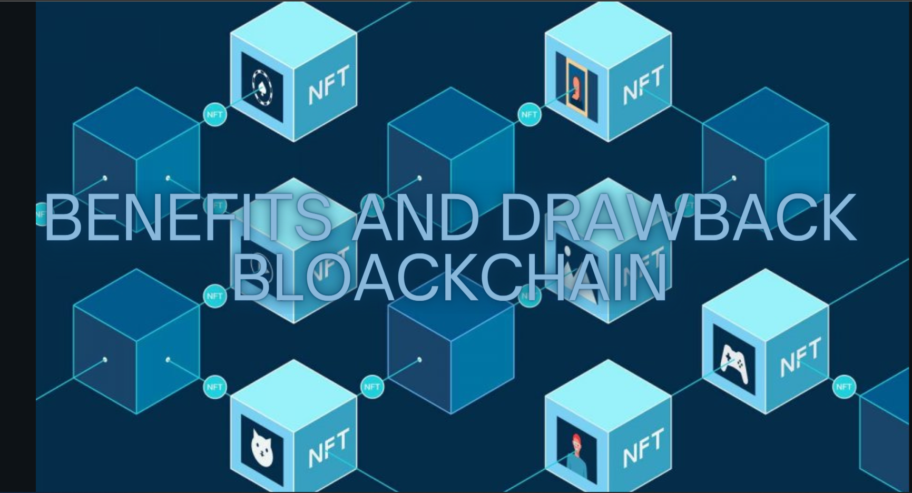

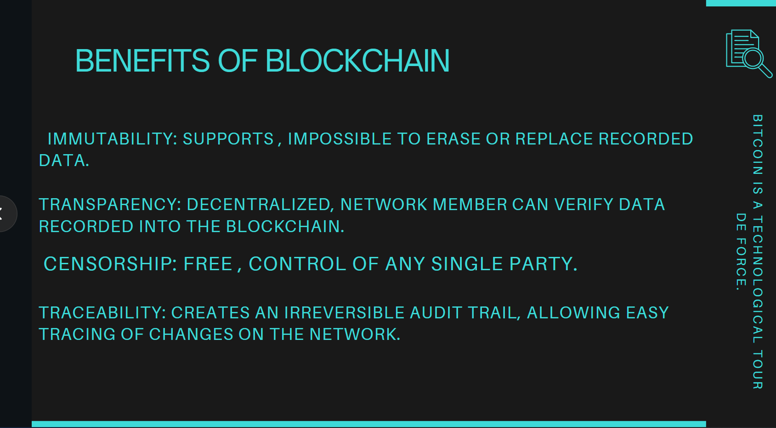

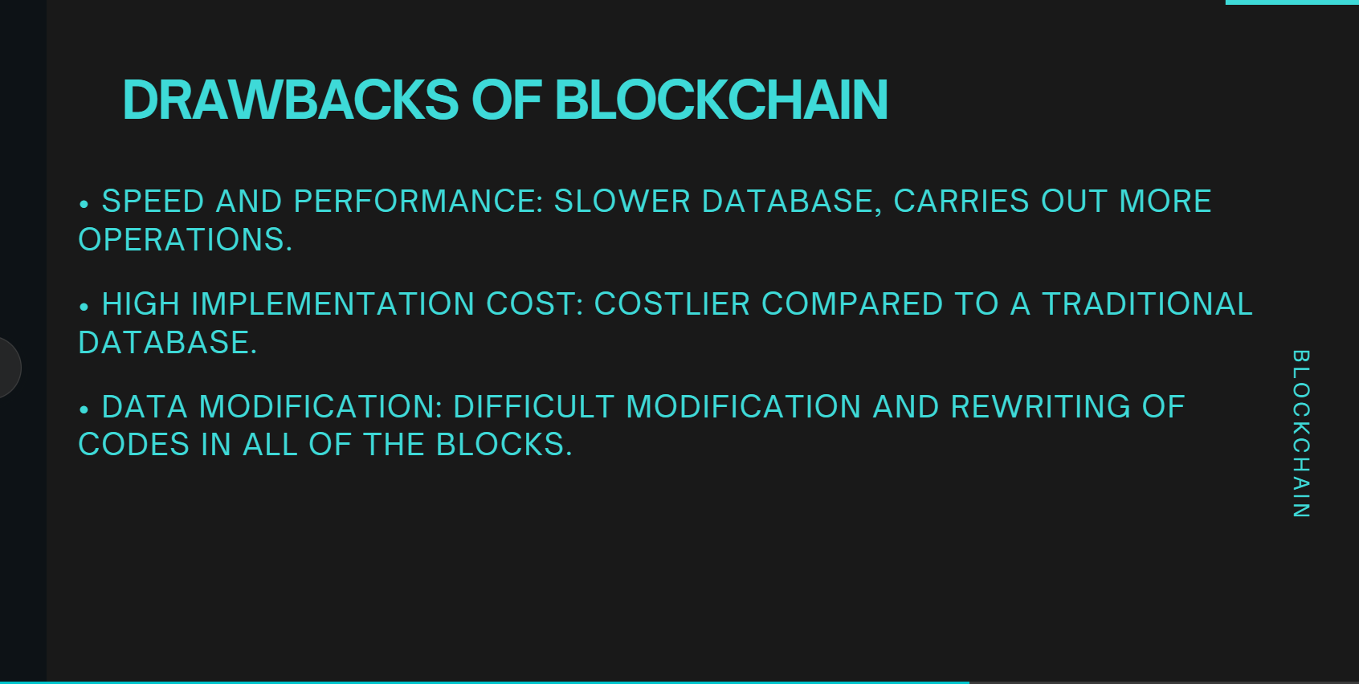

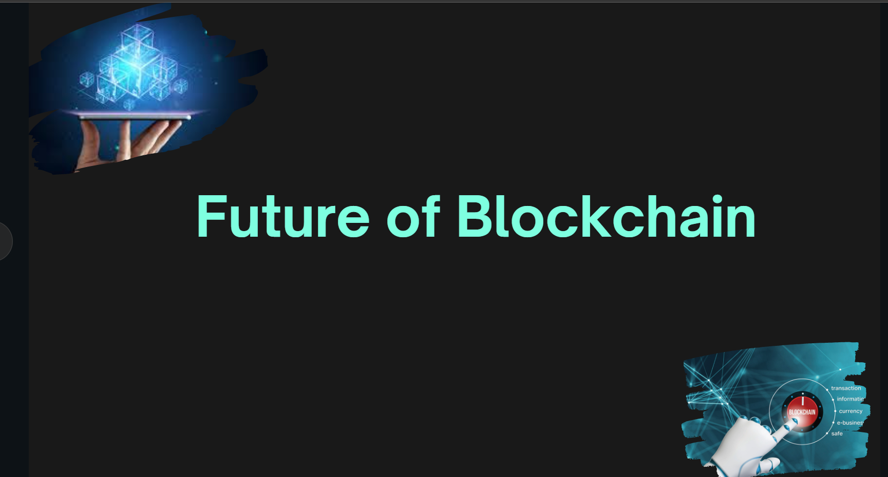

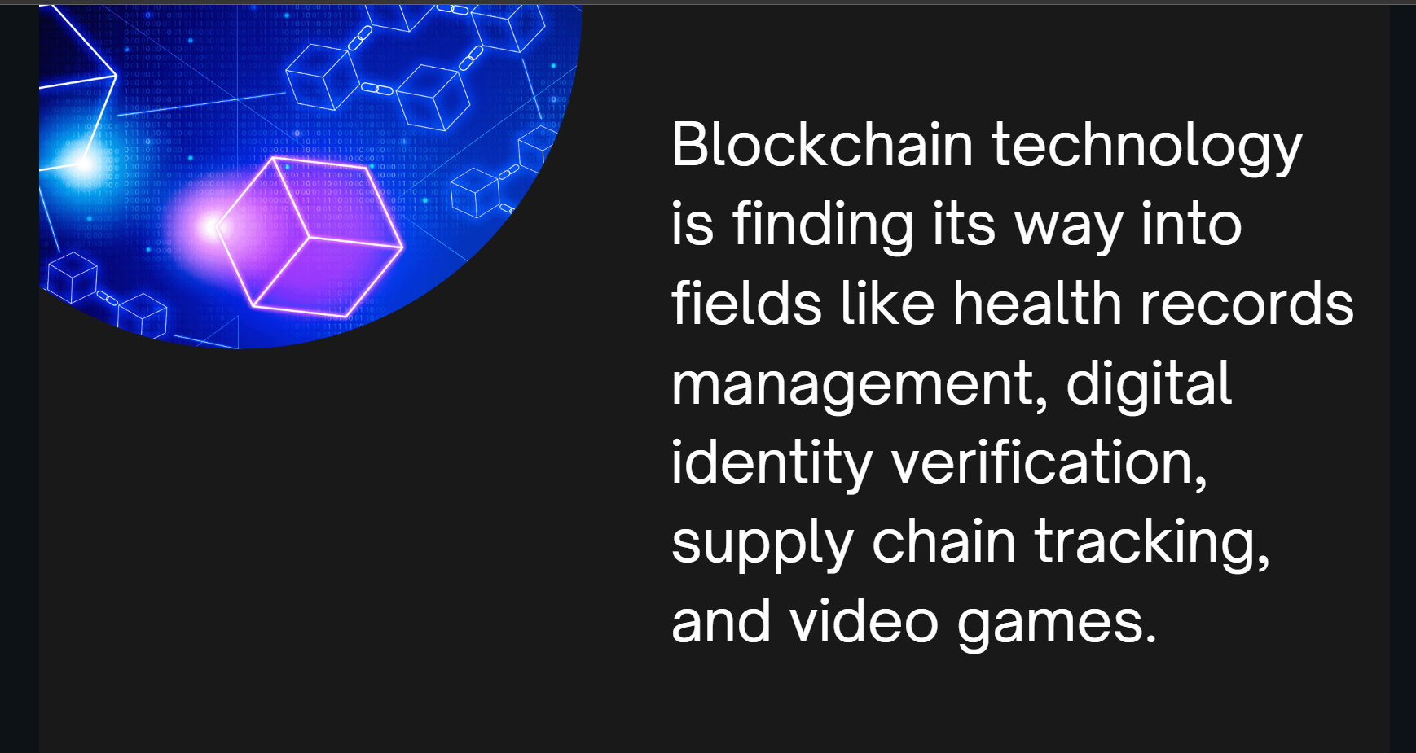







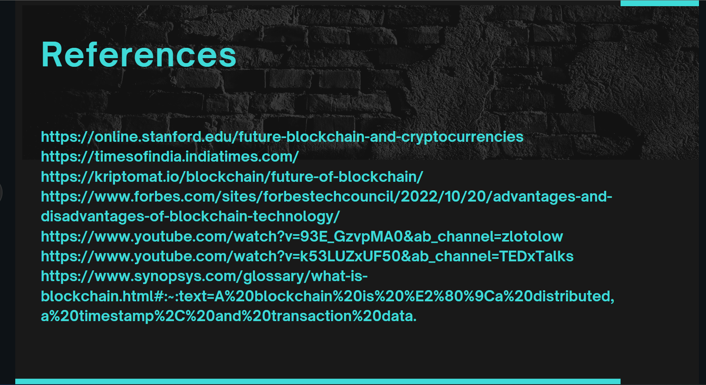

# **8. References**

1. ACM, 2023. *membership/acm-at-a-glance.* [Online]   
   Available at: https://www.acm.org/membership/acm-at-a-glance#:~:text=Introduction,and%20address%20the%20field's%20challenges  
   [Accessed 03 February 2023].
2. ACM, 2023. *membership/acm-at-a-glance.* [Online]   
   Available at: https://www.acm.org/membership/acm-at-a-glance  
   [Accessed 01 February 2023].
3. ACM, 2023. *membership/membership-benefits.* [Online]   
   Available at: https://www.acm.org/membership/membership-benefits  
   [Accessed 03 Februrary 2023].
4. Fuse Machine, 2022. *fusemachines.com.* [Online]   
   Available at: https://fusemachines.com/about/  
   [Accessed 09 January 2023].
5. Herald College Kathmandu, 2022. *Herald College Kathmandu.* [Online]   
   Available at: https://heraldcollege.edu.np/about  
   [Accessed 15 December 2022].
6. Herald College Kathmandu, 2023. *bachelors-in-computer-science.* [Online]   
   Available at: https://heraldcollege.edu.np/bachelors-in-computer-science  
   [Accessed 05 January 2023].
7. IvyPanda, 2023. *essays/association-of-computing-machinery-acm.* [Online]   
   Available at: https://ivypanda.com/essays/association-of-computing-machinery-acm/#:~:text=Disadvantages%20of%20ACM&text=This%20is%20discouraging%20to%20members,related%20expenses%20(ACM%2C%20Inc.  
   [Accessed 03 February 2023].
8. Nepali Times, 2017. *Nepali Times.* [Online]   
   Available at: https://www.nepalitimes.com/here-now/natural-intelligence/  
   [Accessed 22 December 2022].
9. Study In The UK, 2020. *uk-education-system-guide.* [Online]   
   Available at: https://www.studying-in-uk.org/uk-education-system-guide/  
   [Accessed 04 January 2023].
10. Topio Networks, 2022. *Topio Networks.* [Online]   
    Available at: https://www.topionetworks.com/companies/fusemachines-553f68d0b6a9b6dc550019ad  
    [Accessed 19 December 2022].
11. Tribhwan University, 2023. *www.tuiost.edu.np.* [Online]   
    Available at: https://www.tuiost.edu.np/programs  
    [Accessed 06 January 2023].
12. University Grants Commission, 2018. *www.ugcnepal.edu.np.* [Online]   
    Available at: https://www.ugcnepal.edu.np/frontpage/20  
    [Accessed 05 January 2023].
13. University of Wolverhampton, 2022. *university-of-wolverhampton-4037.* [Online]   
    Available at: https://www.prospects.ac.uk/universities/university-of-wolverhampton-4037  
    [Accessed 19 December 2022].

14. https://www.forbes.com/sites/ashleystahl/2022/05/03/the-rise-of-artificial-intelligence-will- robots-actually-replace-people/?sh=3da999bc3299